INPUT CODE
<!DOCTYPE html>
<html lang="en">

<head>
<meta charset="UTF-8">
<meta name="viewport" content="width=device-width, initial-scale=1.0">
<title>ConnectHub - Log In</title>
<style>
* {
margin: 0;
padding: 0;
box-sizing: border-box;
}

html,
body {
height: 100%;
}

body {
font-family: 'Segoe UI', Helvetica, Arial, sans-serif;
color: #1c1e21;
}

.page {
display: flex;
height: 100vh;
min-height: 640px;
}

.left-panel {
flex: 1.4;
position: relative;
padding: 40px 60px;
display: flex;
flex-direction: column;
justify-content: space-between;
overflow: hidden;
}

.logo-mark {
width: 46px;
height: 46px;
border-radius: 50%;
background: #2455e6;
display: flex;
align-items: center;
justify-content: center;
}

.logo-mark span {
color: #fff;
font-size: 26px;
font-weight: 800;
font-family: Georgia, serif;
}

.collage {
position: relative;
flex: 1;
margin: 20px 0;
margin-left: 17rem;
margin-right: -7rem;
}

.card {
position: absolute;
border-radius: 18px;
box-shadow: 0 10px 30px rgba(0, 0, 0, 0.15);
overflow: hidden;
}

.card-photo {
width: 100%;
height: 100%;
display: flex;
align-items: flex-end;
padding: 14px;
}

.card-1 {
width: 300px;
height: 220px;
top: 10%;
left: 8%;
background: linear-gradient(135deg, #7f8fa6, #dcdde1);
}

.card-2 {
width: 300px;
height: 340px;
top: 4%;
left: 34%;
background: linear-gradient(160deg, #ffb199, #ff6f61);
}

.card-3 {
width: 220px;
height: 260px;
top: 46%;
left: 12%;
background: #ffffff;
border: 1px solid #eee;
padding: 12px;
}

.card-3 .thumb {
width: 100%;
height: 70%;
border-radius: 10px;
background: linear-gradient(135deg, #f6d365, #fda085);
}

.card-3 .lines {
margin-top: 10px;
}

.card-3 .lines div {
height: 8px;
border-radius: 4px;
background: #eceef0;
margin-bottom: 6px;
}

.badge {
position: absolute;
border-radius: 50%;
display: flex;
align-items: center;
justify-content: center;
font-weight: bold;
box-shadow: 0 6px 16px rgba(0, 0, 0, 0.18);
}

.badge-time {
top: 18%;
left: 52%;
width: 76px;
height: 34px;
border-radius: 20px;
background: #6c5ce7;
color: #fff;
font-size: 13px;
gap: 6px;
}

.badge-emoji {
top: 8%;
left: 22%;
width: 60px;
height: 60px;
background: #ffd166;
font-size: 28px;
}

.badge-heart {
top: 55%;
left: 46%;
width: 62px;
height: 62px;
background: #ff3b6a;
color: #fff;
font-size: 26px;
}

.badge-store {
top: 22%;
left: 10%;
width: 40px;
height: 40px;
border-radius: 10px;
background: #1c1e21;
color: #fff;
font-size: 16px;
}

.badge-star {
top: 42%;
left: 12%;
width: 40px;
height: 40px;
border-radius: 10px;
background: #2455e6;
color: #fff;
font-size: 18px;
}

.avatar {
position: absolute;
top: 66%;
left: 30%;
width: 100px;
height: 100px;
border-radius: 50%;
background: linear-gradient(160deg, #f9d976, #f39f86);
border: 4px solid #2455e6;
}

.headline {
font-size: 52px;
font-weight: 800;
line-height: 1.1;
max-width: 460px;
}

.headline .accent {
color: #2455e6;
}

.divider {
width: 1px;
background: #dadde1;
margin: 60px 0;
}

.right-panel {
flex: 1;
display: flex;
align-items: center;
justify-content: center;
padding: 40px;
}

.login-box {
width: 100%;
max-width: 380px;
}

.login-box h2 {
font-size: 22px;
margin-bottom: 20px;
}

.login-box input {
width: 100%;
padding: 15px 16px;
font-size: 15px;
border: 1px solid #dddfe2;
border-radius: 8px;
margin-bottom: 14px;
outline: none;
}

.login-box input:focus {
border-color: #2455e6;
}

.btn-primary {
width: 100%;
background-color: #2455e6;
color: #fff;
font-size: 17px;
font-weight: 600;
border: none;
border-radius: 8px;
padding: 13px 0;
cursor: pointer;
margin-bottom: 18px;
transition: background-color 0.15s ease;
}

.btn-primary:hover {
background-color: #1c44bd;
}

.forgot-link {
display: block;
text-align: center;
color: #2455e6;
font-size: 14px;
text-decoration: none;
margin-bottom: 26px;
}

.forgot-link:hover {
text-decoration: underline;
}

.btn-outline {
display: block;
width: 100%;
background: #fff;
color: #2455e6;
font-size: 16px;
font-weight: 600;
border: 1px solid #2455e6;
border-radius: 8px;
padding: 12px 0;
cursor: pointer;
margin-bottom: 30px;
transition: background-color 0.15s ease;
}

.btn-outline:hover {
background: #f0f4ff;
}

.brand-footer {
text-align: center;
color: #8a8d91;
font-weight: 700;
font-size: 15px;
letter-spacing: 0.3px;
}

.lang-footer {
border-top: 1px solid #dadde1;
padding: 16px 60px;
display: flex;
flex-wrap: wrap;
gap: 20px;
font-size: 13px;
color: #737373;
}

.lang-footer span {
cursor: pointer;
}

.lang-footer span:hover {
text-decoration: underline;
}
</style>
</head>

<body>

<div class="page">
<div class="left-panel">
<div class="collage">
<div class="card card-1"></div>
<div class="card card-2"></div>
<div class="badge badge-emoji"></div>
<div class="badge badge-time"></div>
<div class="badge badge-heart"></div>
<div class="badge badge-store"></div>
<div class="badge badge-star"></div>
<div class="avatar"></div>
</div>

<div class="headline">
Explore the things<br><span class="accent">you love.</span>
</div>
</div>

<div class="divider"></div>

<div class="right-panel">
<div class="login-box">
<h2>Log in to ConnectHub</h2>
<form action="#" method="post">
<input type="text" name="username" placeholder="Email address or mobile number" required>
<input type="password" name="password" placeholder="Password" required>
<button type="submit" class="btn-primary">Log in</button>
<a href="#" class="forgot-link">Forgotten password?</a>
<button type="button" class="btn-outline">Create new account</button>
</form>
<div class="brand-footer">◈ ConnectHub</div>
</div>
</div>
</div>

<div class="lang-footer">
<span>English (UK)</span>
<span>ಕನ್ನಡ</span>
<span>اردو</span>
<span>मराठी</span>
<span>తెలుగు</span>
<span>हिन्दी</span>
<span>தமிழ்</span>
<span>More languages...</span>
</div>

</body>

</html>

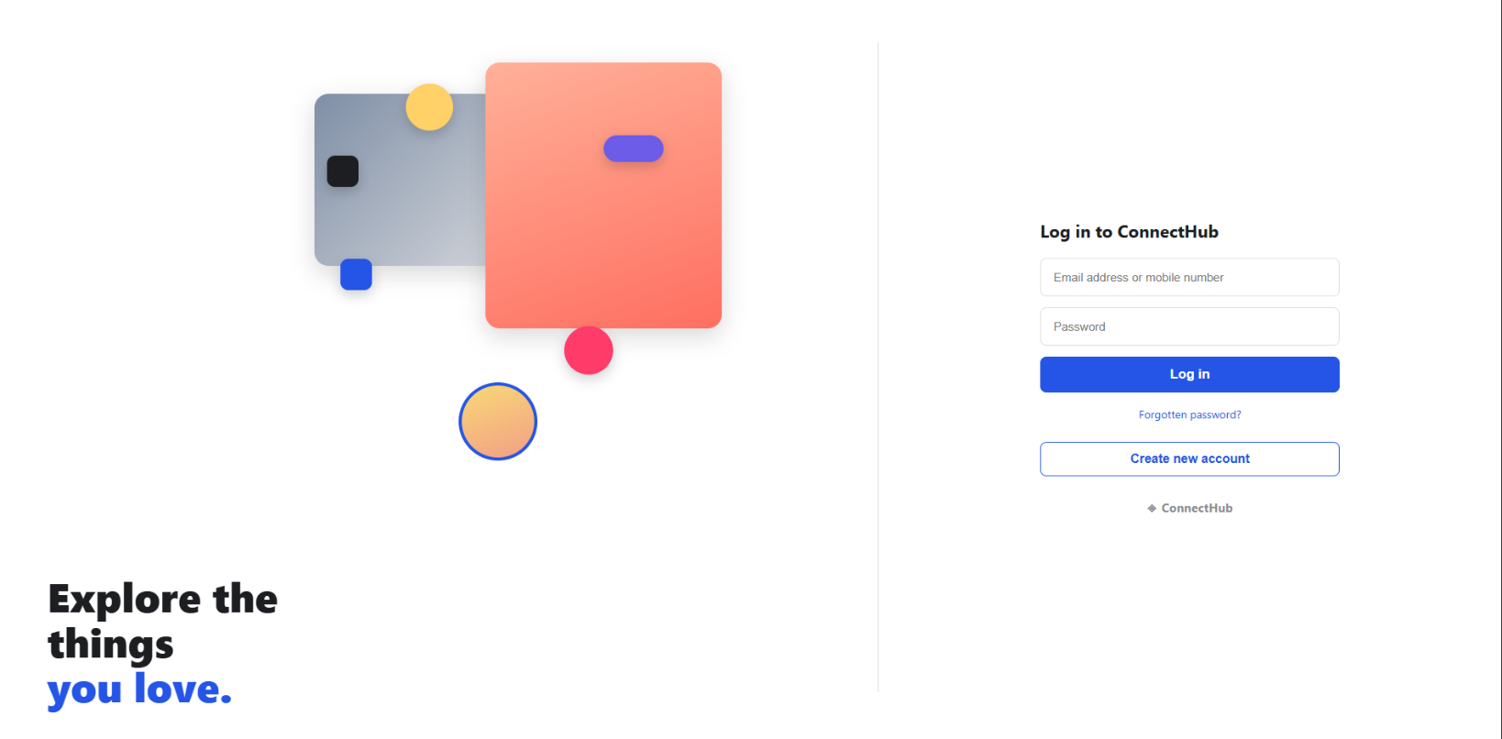
OUTPUT

